

**Project Status Report**

**Project Name: APC Student Assistant System**

**Department: Bachelor of Science and Computing and Information Technology**

**Focus Area:** **Student Assistant Students**

**Product/Process:** **In progress of updating all general information of our system**

**Prepared By:**

|  |  |
| --- | --- |
| **Document Owner(s)** | **Project/Organization Role** |
| Abrera, Jenna Ann B. | Project Documenter/Designer |
| Cruz, Lorenz Matthew M. | Project Developer |
| Romero, Jun Kimuel C. | Project Manager/Web Developer |
| Tomas, Gener Joseph G. | Project Analyst/Developer |

**Project Status Report Version Control**

|  |  |  |  |
| --- | --- | --- | --- |
| **Version** | **Date** | **Author** | **Change Description** |
| 2.0 | 10/03/16 | Romero, Jun Kimuel | Document created |
| 1.8  1.9  2.1  2.2 | 10/03/16  10/05/16  10/05/16  10/03/16 | Abrera, Jenna Ann  Cruz, Lorenz Matthew  Romero, Jun Kimuel  Tomas, Gener Joseph | * We are doing our task that is assign to us for our project and also restaging our own IBM Bluemix account. * We are doing our task that is assign to us for our project and also restaging our own IBM Bluemix account. * We are doing our task that is assign to us for our project and also restaging our own IBM Bluemix account. * We are doing our task that is assign to us for our project and also restaging our own IBM Bluemix account. |

**TABLE OF CONTENTS**

1 PROJECT STATUS REPORT PURPOSE 3

PROJECT STATUS REPORT 3

1.1 Project Status Report Details 3

1.2 Project Status Report 4

2 PROJECT STATUS REPORT APPROVALS 7

3 APPENDICES 8

3.1 Document Guidelines 8

3.2 Project Status Report Sections Omitted 8

# PROJECT STATUS REPORT PURPOSE

To detail the things needed to do in order to complete the requirements for the subject.

# PROJECT STATUS REPORT

## Project Status Report Details

* Project Description
  + Student Assistant who perform their given task for their scholar funding.
* Budget Report

O To contribute at least 50 pesos each member per week for the expenses for the project.

* Risk Management Report

O We tackled each idea for our project that supports the things that we can help us in doing our project.

O If we don’t able to reach the expectation of our professor.

* Issues Report

o Pressure of the members to finish the project before or on schedule.

O Having a hard time in combining the idea of each member.

* Project recommendations to ensure success including lessons learned.
  + Always cooperate with your group mates to accomplish the task needed to do.

## Project Status Report

|  |  |  |
| --- | --- | --- |
| **APC Student Assistant System** | | |
| Prepared by:  Abrera, Cruz, Romero, and Tomas | Date:  10/03/16 | Reporting Period:  10/03/16 to 10/06/16 |
| Project Overall Status:  We start in brainstorming of each member’s idea that can help us in doing our project and also maximizing the free time of each member’s. | | |
| Project Summary:  This project will help the Disciplinary Office Head to minimize the time of checking the paper of each student and also to be able to record all the information that the student will pass for their Student Assistant task. | | |

|  |  |  |  |  |  |
| --- | --- | --- | --- | --- | --- |
| **Milestone Deliverables performance reporting over last period** | | | | | |
|  | **Milestone Deliverables** | **Due Date** | **% Completed** | **Deliverable Status** |  |
| Milestone 1 |  | | |
| • We are trying to finish the restaging part for our IBM Bluemix account. | 10/7/16 | 100% | **Behind Schedule** |
| • We get some great ideas from each member that can really help us in doing our project. | 10/3/16 | 100% | **Behind Schedule** |
| • We give each member the things that they need to finish in the specific time for us not to cram in creating our project. | 10/5/16 | 100% | **Behind Schedule** |
|  | **Milestone Deliverables schedule** | **for completion over next period** | | | |
| **Milestone Deliverables** | **Due Date** | **% Completed** | **Deliverable Status** |  |
| Milestone 1 |  | | |
| • Need to finish the IBM Bluemix. | 10/08/16 | 90% | **On Schedule** |
| • To start the scope and and vision of our project | 10/14/16 | 0% | **Behind Schedule** |
| • We, the members should have a meeting at least for one whole day. | 10/12/16 | 0% | **Behind Schedule** |

|  |  |  |  |  |  |
| --- | --- | --- | --- | --- | --- |
|  | **Project impact of milestones** | **success or failure for project remainder** | | | |
| Our members give some ideas about our project and distribute the specific task for each member. |  | It’s a success since it will help us to maximize the time of each member and for us to finish the things that we need to pass on/before the deadline. | |  |
|  | **Project** **Budget/Financial Status** |  | | | |
| **Budget Item** | **Planned Budget** | **Actual Cost** | **Variance/Explanation** |  |
| Fare (estimated per day) | P 150.00 | P 120.00 | Fare expenses during meeting. |
| N/A | N/A | N/A | N/A |

|  |  |  |  |  |  |  |
| --- | --- | --- | --- | --- | --- | --- |
| **Project Risk Management Status** | | | | | | |
|  | **Risk and Description** | **Risk**  **Chance** | **Risk Impact** | **Risk**  **Priority** | **Change from Last Review** |  |
| • If we don’t able to reach the expectation of our professor. | High | High | High | Adjusting of each member and to practice ourselves to be practical in everything. |
| * N/A | N/A | N/A | N/A | N/A |
|  | **Project Issue Management Status**   |  |  |  |  |  | | --- | --- | --- | --- | --- | | **Issue and Description** | **Project Impact** | **Target**  **Due Date** | **Issue Status** | **Issue Resolution** | | • Having a hard time in combining the idea of each member. | Medium | High | Medium | We should be more practical and cooperate in the group. | | • N/A | N/A | N/A | N/A | N/A | | | | | | |
|  | **Project Recommendations** | | | | | |
| * Will the project be completed on time and on budget? Yes * Will the project deliverables be completed within acceptable quality levels? Yes * Are scope change requests being managed successfully? Yes * Are project issues and risks being addressed successfully and mitigated? Yes * Are all customer concerns being addressed successfully? Yes | | | | |  |
|  | **Objectives for Next Project Status Review** | | | | | |
| If we work with the emotions of guilt and laziness, but in the end work as together the outcome will be more analytical in different kind of perspective. We expect to finish the requirements behind the schedule to have more time to work in our project aside from passing it on time. | | | | |  |

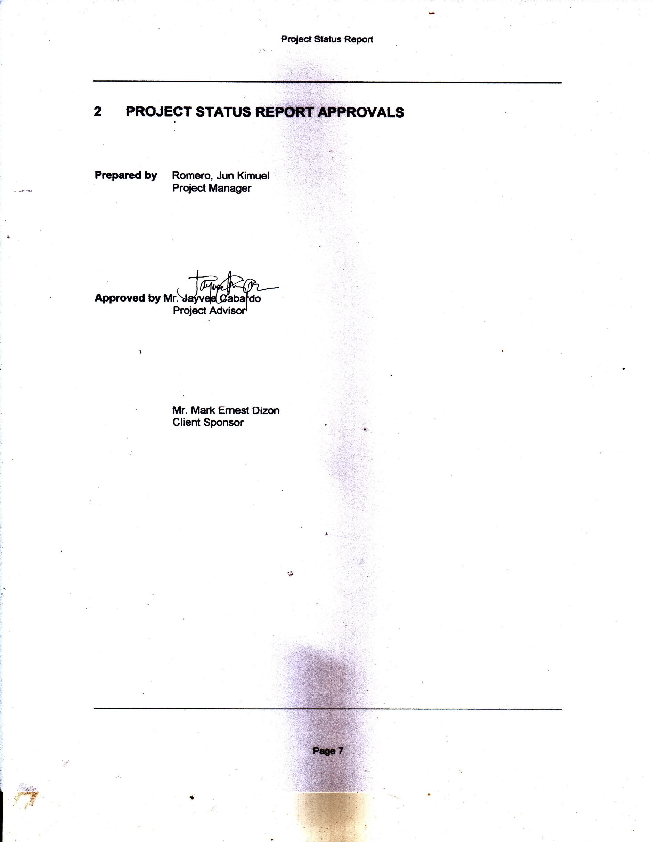

# PROJECT STATUS REPORT APPROVALS

**Prepared by** Romero, Jun Kimuel

Project Manager

**Approved by** Mr. Jayvee Cabardo

Project Advisor

Mr. Mark Ernest Dizon

Client Sponsor

# APPENDICES

## Document Guidelines

## Project Status Report Sections Omitted